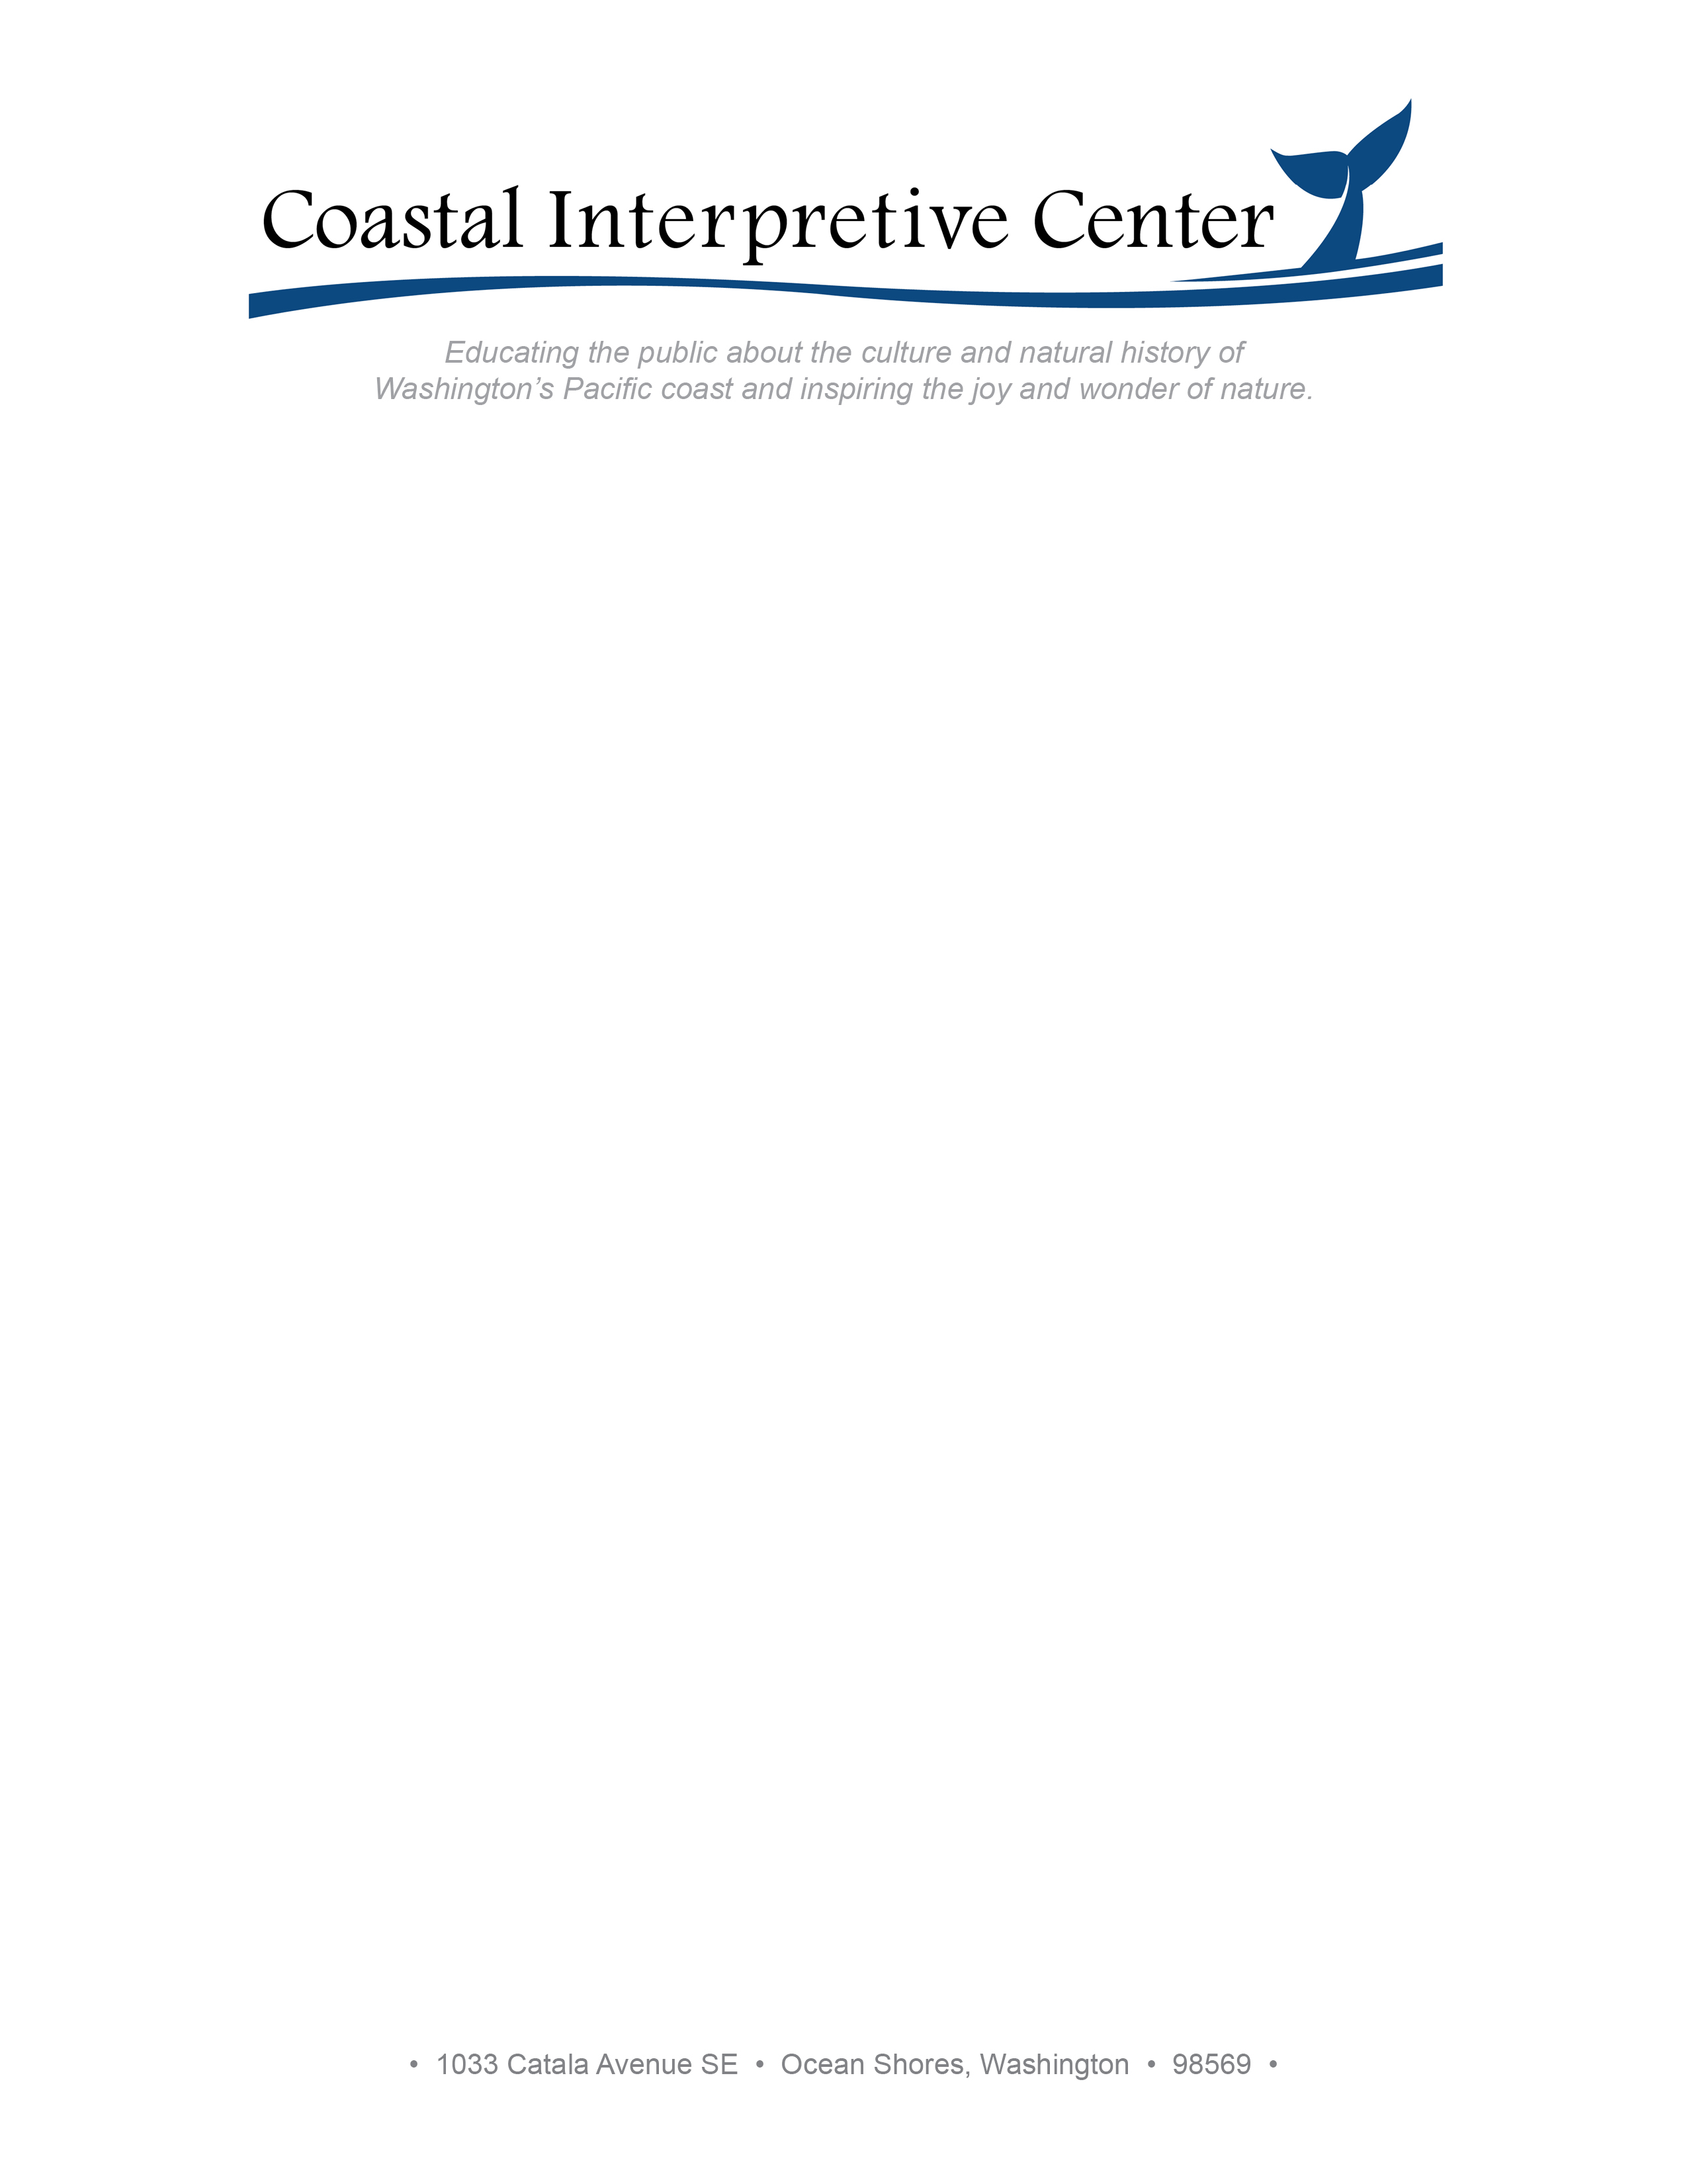

Summer 2025

Raffle Item Donor:

The Coastal Interpretive Center is planning a “End of Season Picnic & Raffle” on September 13. We are soliciting raffle items to help with our fundraising goals. Your donation will help support all the work we do to educate children and adults alike about our amazing Washington coast.

Attached is our Donation Procurement Form that you can use for tax purposes.

You can reach us at the phone numbers and/or email addresses listed below. Thank you for your kind consideration.

Sincerely,

Nancy K. Eldridge
360-589-7189
neldridge@interpretivecenter.org

Tina James
206-909-6833
tjames@interpretivecenter.org

Beth Olszak
206-709-0579
bolszak@interpretivecenter.org

