**TOGETHER WE'RE SUCCESSFUL**

Founded in 1977, the Coastal Interpretive Center has served visitors for nearly fifty years. Beginning with our museum, we have expanded to embrace our role as a cultural and natural history organization offering educational programs for students, volunteer community science opportunities, and outdoor events across the Washington coast.

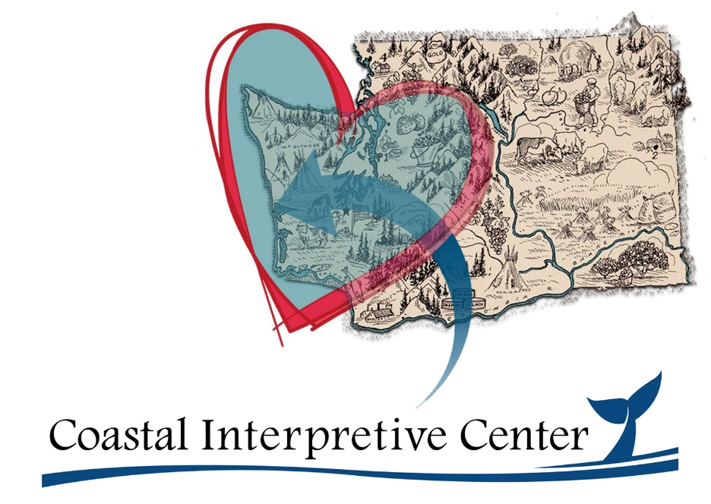

**WE'RE AT WORK** to educate the public about the cultural and natural history of Washington’s Pacific coast and inspire the joy and wonder of nature.

**OUR MISSION AREA** includes the area from the Columbia River northward to Cape Flattery and eastward from the continental shelf to watersheds draining into the Pacific Ocean.

**WHAT IS AN INTERPRETIVE CENTER?**

**Interpretive Centers**present user-friendly, hands-on experiences that are focused on teaching visitors about the cultural and natural resources of a specific area.